This is the before of the musical piece that I made what this consists of are the loops notes of instrument and there chords as well as a drums maker as well.

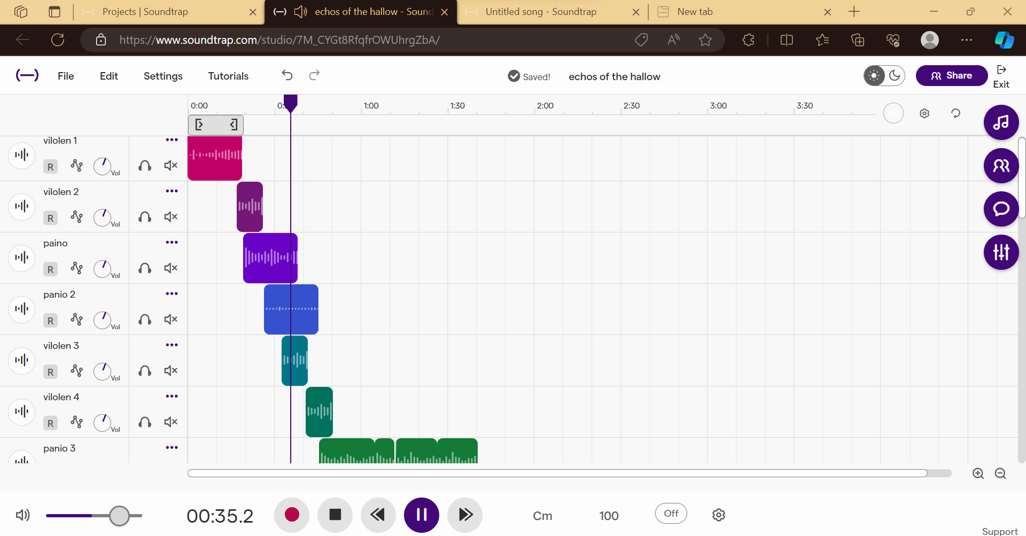

This was the first part of the song which starts off with a couple of notes on the violin and then starts to use some chords then transitions into the piano which I used basic chords to make the key that this started in was d minor but I thought that it was best to switch it to C minor to give the sad effect a better base to stand on and then I add drums which In this it has got miss labeled to piano 2 but this is drums which do set the speed at which the rest of the song will go but this does not stay for long because I switch to over to violin notes and chords and well as more piano and repeat using these instruments to get the effect that was achieved for this piece

There are vocals as well that come partway through the song which I did sample from a third party sources that is attached to this website.

I made another music project after this one

In this one I do use more sample sounds up at the top the voices in this one are sample sounds but the rest are chords and notes from other instruments such as pianos bass drums and the synthesizer all of the instruments work to make the song good the tools that I use are the loops piano roll to use the nots and the same for the chords. Some of the ways that you can use to make some of the notes are to find each note in the list and then set the length of them and volume plus other FX as well such as reverb and EQ and more for the chords you do the same find them in the list and set time and length but if you want to make them sound really good you could do each note of the chord individually which is quite hard which I did not do. But those are the methods that I use for this and the one that I did before this one.

The third song this one is simple but it does sound quite good it is more peaceful than the other ones the way that I achieved this was through temp chords and voice what I did was that I did a lead in using the panino and synthesizer this one only has one sample sound which is the to blue chords at the bottom the rest of the chords and notes list that is in sound trap I slowed the temp on this one giving it a more peaceful tone and then use the voice and the piano to put the final touches on to the peace and making it a nice and peaceful part of the music collection that I have made. **A screenshot of a computer
**